Can YOU HELP?
  - Save Washington Park Cemetery!
100th Anniversary  Restoration Project  ​  Washington Park Cemetery, the historic African American cemetery located right next to Lambert Airport, is in its 100th year! Many news programs have reported that nearly 39 acres of the approximately 42-acre historic cemetery are in a wretched state of neglect and disrepair.  We have begun a multi-year effort to turn the cemetery into a beautiful north St. Louis County heritage site for these former St. Louisans, their families and descendants to come! But we need your help!  For More Information  Facebook.com/SavingWashingtonPark | 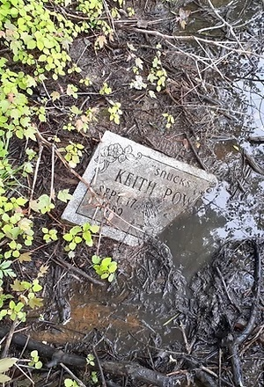  Immediate Need​  To offer your support or  in-KIND assistance  314-494-0600  Or to get involved in this historic effort made for future generations, please call us at your earliest convenience.
Visit the “Help” page at
SavingWashingtonPark.com

SAVE THE DATE:
Community CleanUpDay – August 15th

Washington Park Cemetery is the final resting place for over 40,000 people, and for many years was one of few cemeteries where the black community could bury their deceased. Revered ministers, respected educators, a noted civil rights leader, and beloved family members are not the only ones buried at the cemetery. ​Many U.S. servicemen chose to be buried by family members and near the homes of their survivors as opposed to the rather far away Jefferson Barracks Cemetery. Veterans buried at the cemetery have served in the Spanish American War, World War I, World War II, the Korean War, and the Vietnam War. With military stones found destroyed throughout the cemetery - that once represented their devoted service in five U.S. wars - survivors are lamenting their veterans’ decisions to be buried at the deteriorating Washington Park Cemetery which has no perpetual care funds left.

SPONSORED BY: Our St. Louis History

www.SavingWashingtonPark.com | 314.494.0600| OurStLouisHistory@gmail.com

Please call any time (day or evening) to offer ANY assistance!

